REVIEW ,NRK
A list of ways to save the world
Anja Røyne gives us an overview of practical suggestions for how we can fix the climate, presented in a way that makes sense – and induces only a mild headache.
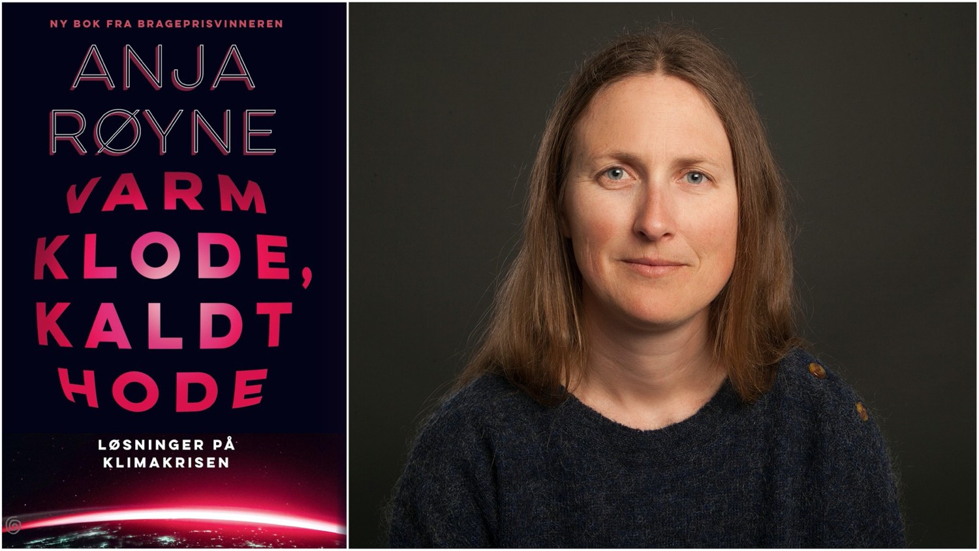
Book

Hot Planet, Cool Head
Anja Røyne
Non-fiction 2020
Kagge

Ola Hegdal
Literary critic

Published 8 December at 15:07

She is a physicist and science communicator, and has already won a Brage Prize for her book
The Elements We Live By. Now Anja Røyne is upping the ante to focus on the really big issues: the climate crisis and what we can do about it.

If you go into this book expecting a quick formula for how to fix the planet, you will soon be disappointed. None of these solutions are free of undesirable side effects, not to mention the political challenges of getting everyone in the world to work together.

The biggest problem is that any tactic that has a hope of affecting the earth’s atmosphere will inevitably be of a very large scale.

Such enormous measures are expensive, and will require vast quantities of resources in the form of metals, concrete, and energy. And the insatiable need for resources and energy is exactly what got humanity into this situation in the first place.

As a result of this, the more radical members of the environmental movement tend to distance themselves from science and progress, which is the source of the problem, and instead wish to go back to a simpler, more basic lifestyle.

Røyne, however, is no Luddite. She agrees that reducing consumption is one part of the solution, but this alone is not enough. She emphasizes technology as a good we cannot do without, which has granted us a standard of living that previous generations could have hardly even dreamed of. Therefore, if we are to avert the threat of global warming, we must do so with the help of technological solutions that only science can provide us with.

Include the impossible
The book is a survey of several possible methods of getting global warming under control. Røyne goes into detail on everything from CO₂ capture and sequestration through regenerative agriculture, to more spectacular – and therefore riskier – solutions, such as fertilizing the oceans with iron.

Or how about spraying a layer of sulfur particles into the upper stratosphere that protects us from solar radiation?

At this point, some readers will probably back away in fear, with images of mad scientists in their heads. Was it not precisely this kind of megalomaniacal intervention in nature that created the problems we are struggling with today?

Røyne admits that she herself reacts skeptically to the more grandiose plans. She rejects a number of them too, like fertilizing the oceans to increase the growth of carbon-binding algae.

I think her approach to these problems – and the solutions – is balanced and correct: assemble an overview of all the possible tactics, and include some impossible ones. Discard the most radical ideas, at least for now. But be prepared to override your knee-jerk reactions.

The situation will require drastic measures, and many old taboos will likely have to give way.

Extremely complex mechanisms
According to Røyne, we have a good understanding of the physical and chemical processes that affect the climate. But the complexity of these systems is so great that it is difficult to find an action that affects the exact thing you want to do something about, without also affecting everything else at the same time.

Many seemingly positive climate measures have unanticipated side effects, which in the short term work against the ultimate goal.

One example is the idea of planting more trees. Trees take in carbon dioxide and store it as carbon. So more trees would reduce the CO₂ content in the air and help to lower the earth’s temperature. Right?
According to Røyne, the answer is yes – and no. In northern regions, more trees will often mean dark coniferous forests that absorb more heat from sunlight, and will therefore contribute to increasing the temperature.

But what about fossil fuels, surely those are indisputably bad? Røyne agrees completely that we must cut emissions from fossil fuels as much as possible, and switch over to other energy sources such as wind, solar, and hydropower, and even nuclear power.

Nevertheless, it is true that the dust and fumes from fossil fuels are currently blocking a certain amount of solar radiation. The short-term effect of eliminating all fossil fuel consumption on earth would therefore not be to reduce the average temperature, but to increase it by about half a degree.

Insight and headaches
Here the reader may feel a touch of despair, because when even well-intended, committed efforts work against their aims, what should we do?

For me, the despair is quickly replaced by gratitude, because it is precisely this information that shows Røyne’s goal is not to push politics or propaganda, but to present an honest depiction of what reality looks like and what we can do about it.

Despite the grim prospects and the overwhelming complexity, Røyne makes an effort to emphasize optimism and hope. We now know much, much more than we used to. Without science, we wouldn’t have known anything about the problems we are facing.

The alternative, to live in blissful ignorance until parts of the globe suddenly become uninhabitable, is not something to wish for. So the hope lies in knowledge and science, even if they, too, have unexpected side effects – like a vague sense of confusion and a mild headache.

I strongly recommend Anja Røyne’s book to anyone who sees the climate question not as a primarily moral problem, but a practical one, and who wants to find out what we can do about it. But don’t expect simple solutions or a quick fix.

Hot Planet, Cool Head is not the book for those who want to sleep well at night. This is the book for those who want to think critically while they lie awake.

PHOTO: KAGGE FORLAG

Title: Hot Planet, Cool Head
Subtitle: Solutions to the Climate Crisis Author: Anja Røyne
Genre: Nonfiction Publisher: Kagge Year: 2020

